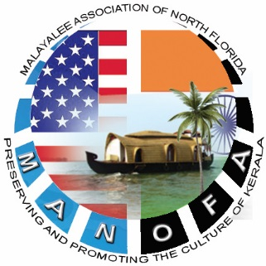
MALAYALEE ASSOCIATION OF NORTH FLORIDA
Jacksonville, FL
Ph: (904) 567-6737
(501(c3) Non-Profit Organization)
16-1776909

APPLICATION FOR MEMBERSHIP – YEAR : 2019

New Renewal

- Name of Member 1:________________________

- Member 1 Email ID :_______________________

- Name of Member 2:________________________

- Member 2 Email ID:__________________________

- Contact Phone :_______________________

- No. of Children :________________________

Family Fees - $40 / Single Fees - $25

**For Office Use Only**
Received By | Date | $ Amount Collected |  | Approved By
 |  |  | Cash Check
*Please make Checks payable to “MANOFA” and hand over to any MANOFA Executive Committee Member
Phone: (904) 567-6737 Email : info@manofa.org | Web: http://www.manofa.org

