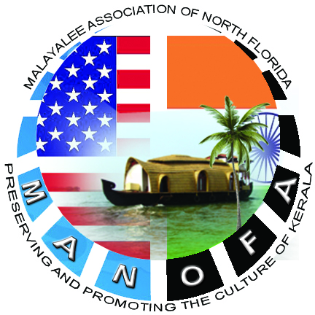
MALAYALEE ASSOCIATION OF NORTH FLORIDA
Jacksonville, FL
Ph : (904) 567-6737
(501(c3) Non-Profit Organization)
16-1776909

APPLICATION FOR MEMBERSHIP – YEAR : 2014

New Renewal
 |  | Last |  |  |  | First |  |  |  |  | Middle
Name
Spouse Name
Address |  | Street |  |  |  |  |  | City |  |  | State |  | Zip
Telephone : Home |  |  |  |  |  | Email Address
Telephone : Mobile |  |  |  |  |  | Alternate Email
Profession |  |  |  |  |  | Personal Interests (Arts/Sports)
Particulars Of Family Members (Children/Parents)
# | Name |  |  |  | Relationship |  | *Age (Children) |  |  | Personal Interests
1
2
3
4
* (Children up to Teenagers – please include Age to determine eligibility requirements for various Sports & Cultural Programs)
ANNUAL MEMBERSHIP FEE: *$40.00 (family) / *$20.00(Individual)
Valid for 1 Calendar Year: Jan - Dec (Should be renewed yearly)
I/We hereby elect to become member/s of Malayalee Association of North Florida, Inc. (MANOFA). I/We also agree to abide with the Rules and Regulations (By-Laws) of the Association. By signing below, I/We also authorize MANOFA and its authorized personnel to contact me/us by Phone, Email or US Postal Services. I/We understand “MANOFA” will protect my/our privacy and keep all personal data as confidential records.
Applicant's Signature |  |  |  |  |  |  |  |  | Date

**For Office Use Only**
Received By | Date | $ Amount Collected |  | Approved By
 |  |  | Cash Check
* Please make Checks payable to “MANOFA” and mail to: 10521 Lantana Lakes N, Jacksonville, FL 32246 or hand over to any MANOFA Executive Committee Member.
Phone: (904) 567-6737 Email : info@manofa.org | Web: http://www.manofa.org

